Banner Finance Approvals
Originator Guide - Accounting JVs

Western Washington University
Business and Financial Affairs
08-Oct-2020

Contents
Introduction 4
JV data-entry: FGAJVCD or FGAJVCM 4
JV document text: FOATEXT 5
Attachments: OnBase 5
Banner Navigation/Actions 6
Rule Classes 7
Creating a JV on FGAJVCD 8
Entering the header on FGAJVCD 8
Entering the explanation on FOATEXT 9
Entering detail on FGAJVCD 10
Completing the JV on FGAJVCD 13
Creating a JV on FGAJVCM 14
Entering the header on FGAJVCM 15
Entering default values on FGAJVCM 15
Entering the explanation on FOATEXT 16
Entering detail on FGAJVCM 17
Completing the JV on FGAJVCM 20
Creating Document Text on FOATEXT 21
Adding Attachments with OnBase 23
Logging into OnBase 23
The OnBase application will open: 23
Logging out from OnBase 24
Viewing JV Details or Approval History in Web4U 25
Opening a separate OnBase window through Web4U 25
Viewing JV details on Web4U 26
Viewing JV approval history on Web4U 27
Printing JV details or approval history on Web4U 28
Approval/Disapproval Messages on GUAMESG 29
Viewing GUAMESG messages 29
Completing GUAMESG messages 31
Disapproved Documents 32
Correcting the JV 32

Introduction

This document provides instruction for originators of accounting journal vouchers.
An originator is the person who keys a JV into Banner and submits it for online approval.

For each accounting JV, an originator will perform three activities, in this order:
- Create the JV in Banner (see pages 8, 14, 21)
- Attach supporting documents using OnBase (see page 23)
- Complete approval/disapproval messages (see page 30)

When the originator completes the JV, it automatically enters the JV approvals stream. One or more approvers will then approve it using Web4U. If necessary, the originator can view the details and/or approval history for their JV, using the “View Document” feature on Web4U Finance. (see page 26)

For each approval (or disapproval), the originator will receive a message in Banner. These messages need to be marked “complete”, in order to keep the message list up-to-date. (see page 30)

If a document is disapproved, the originator should check the message sent by the disapprover to see if the JV is being completely rejected, or just needs correction. If appropriate, they can correct it on the JV form, and submit it for re-approval . (see page 33)

JV data-entry: FGAJVCD or FGAJVCM

Two Finance forms are available to key accounting JVs for departmental approval:
- FGAJVCD – Journal Voucher Entry Form
- FGAJVCM – Journal Voucher Mass Entry form

Here are the differences between them:
Form | Display format | Document Reference #
FGAJVCD | Two-page data entry  Displays one detail record at a time  Fields scattered across the page  All fields visible without scrolling | Available
FGAJVCM | One-page data entry  Displays twelve detail records at a time  Spreadsheet-style columns  Must scroll left-to-right to see all columns | Not available

Use of document reference numbers is optional, e.g. if correcting a previous transaction, you could enter its document number in the Doc Ref # field. This field appears on a few reports such as FBTD02, FBTD03, and WOPACCT. If you wish to include a document reference number, use the FGAJVCD form. Otherwise, the choice of form is a matter of personal preference.

JV document text: FOATEXT

All accounting JVs require an explanation to describe why the JV is being created. This explanation will be considered by Accounting Services and other approvers when they are reviewing the JV, and determining whether or not to approve it.

The JV explanation will be entered as document text on form FOATEXT. This form is available from both FGAJVCD and FGAJVCM, via the Options menu.

Attachments: OnBase

Supporting documentation can be “attached” to each accounting JV using OnBase. OnBase permissions will be granted to both originators and approvers:
- Originators need access to attach supporting documents to the JVs they’ve created
- Approvers need access to review attachments when deciding whether to approve the JV

Here are some of the features of OnBase:
- Login is via Single Sign-on using your universal login and password.
- Journal Voucher back up documentation can be retrieved or queried by OnBase Document type and associated keywords or date range.
- Users can browse their desktop, My Documents, C: drive, or network drive for attachments, then drag-and-drop copies of those documents into OnBase via Import.
- Any number of attachments can be added to the OnBase System. Note, the Journal Voucher Number Keyword is a required field.
- Attachments can include PDF files, Banner reports, Excel spreadsheets, Word documents, or images in JPG, TIF, or GIF format.
- Annotations such as boxes, highlighting, or “sticky note” comments can be added to these attachments. They are added only to the OnBase copy, not to the original document.

Banner Navigation/Actions

Banner allows you to navigate and perform actions using keystrokes, icons, or menu selections.

The menu and icons are located below the Banner session title:
Menu bar
Banner session title
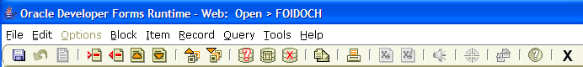

Icon toolbar

Scattered throughout these instructions, you’ll see boxes that look like this:
Next Block <Ctrl-PgDn> or or Block, Next

These boxes appear when you need to perform a specific action in a Banner screen. The box shows the different ways the action can be performed. For example, the box above shows the three different ways that you can perform a “Next Block” action:
- Keystrokes: Hold down the <Ctrl> key, then hit the <PgDn> key
- Icon: Click on the indicated icon
- Menu: Select “Block”, then “Next” from the menu

Here’s a list of navigations/actions that are useful when keying JVs:

Navigation/Action | Keystrokes | Icon | Menu Selection
Move to next field | Enter or Tab | n/a | Item, Next
Move to previous field | Shift-Tab | n/a | Item, Previous
Move to next record | Down arrow |  | Record, Next
Move to previous record | Up arrow |  | Record, Previous
Move to next block | Ctrl-PgDn |  | Block, Next
Move to previous block | Ctrl-PgUp |  | Block, Previous
Insert new record | F6 |  | Record, Insert
Duplicate record above into current record | F4 | n/a | Record, Duplicate
Delete current record | Shift-F6 |  | Record, Remove
Clear data from current record | Shift-F4 | n/a | Record, Clear
Save | F10 |  | File, Save
Exit (form or Banner) | Ctrl-Q |  | File, Exit

Rule Classes

Rule classes determine how transactions post to the operating and general ledgers in Banner. Each rule class has its own requirements for balancing within the document.

Below is a listing of rule classes that can be used for accounting JVs, with a description to indicate when each should be used, and their balancing method:

Rule Class | Description | Balancing
General-purpose
J079 | For JVs within one fund, one chart. Must be balanced by fund.  Uses “DR” or “CR”. | Within fund
J096 | For JVs with multiple funds, same chart. Must be balanced by chart. Uses “DR” or “CR”. | Within chart
J089 | Can be used on JVs that cross charts. Must be balanced in total.  Uses “DR” or “CR”. | In total
Specialized
CD20 | For one-sided transactions to record cash activity.  Self-balancing (cash entry automatically created). Uses “+” or “-“. | Self
TRAV | For use by Travel Desk only.  Clone of J089. | In total

Creating a JV on FGAJVCD

To begin data-entry, type “FGAJVCD” in the Go box on the Banner main menu. The form will open, with the cursor in the Document Number field:

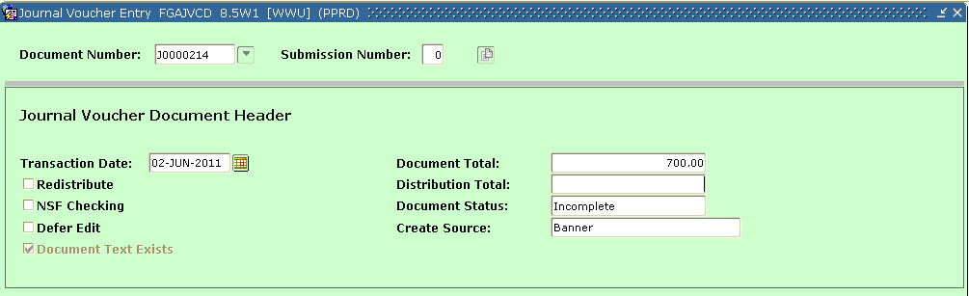

Document Number: Leave this blank to have Banner assign an 8-character document number that starts with a “J”, e.g. J0000214. Or, enter your own number. (Banner will prevent you from entering a document number that has already been used.)

Submission Number: Leave the default value “0” (zero).

□ □ □

Move to the next block to enter the header.
Next Block <Ctrl-PgDn> or or Block, Next

Entering the header on FGAJVCD

Transaction Date: Defaults to the current date. If desired, change to any date in an open period. This determines the fiscal period for posting.

Redistribute: Leave this field blank.

NSF Checking: Leave this field blank.

Defer Edit: Leave this field blank.

Document Text Exists: Display-only. Grayed-out if no explanation (document text) has been entered. Will display a tickmark when document text has been entered.

Document Total: Enter the amount which is the sum of the absolute values of the accounting sequences you will enter. For example, if you’ll be entering a debit for 250.00 and a credit for 250.00, the document total will be 500.00.

Distribution Total: Leave this field blank.

Document Status: Display-only. Will say “Incomplete”.

Create Source: Display-only. Will say “Banner”.

Entering the explanation on FOATEXT

To enter an explanation for this JV (mandatory), turn to page on page 21 and follow the instructions for data-entry on FOATEXT. When you’re done, return to this page.

□ □ □

When an explanation has been entered, move to the next block to enter the detail (accounting sequences).
Next Block <Ctrl-PgDn> or or Block, Next

Tip: Your Banner-assigned Document Number will now be displayed.
Before going any further, write this number down.
You’ll need it later when attaching images in OnBase.

Entering detail on FGAJVCD

The Document Number and Total will display at the top of the screen. The cursor will be in the Sequence field:

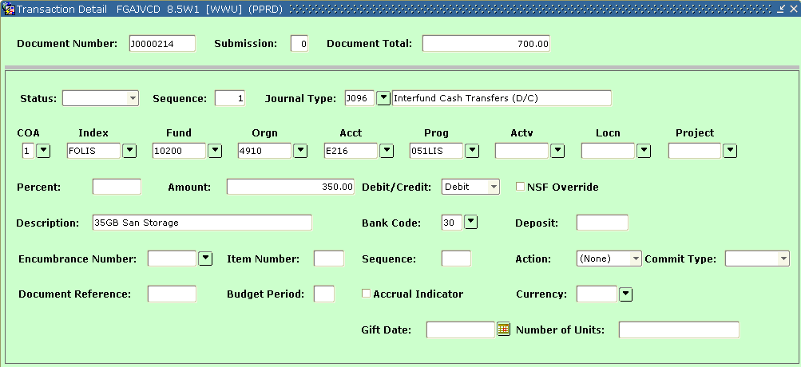

Status: Leave this field blank. Banner will populate.

Sequence: Leave this blank. Banner will assign a sequence number as you exit the field.

Journal Type: Enter the appropriate rule class – see the list on page 7.

COA: Enter the chart for this sequence.

Index: (optional) Enter the fast index for this sequence.

Fund: Enter the fund code for this sequence.

Orgn: Enter the organization code for this sequence.

Acct: Enter the account code for this sequence.

Prog: Enter the program code for this sequence.

Actv: (optional) Enter the activity code for this sequence.

Locn: (optional) Enter the location code for this sequence.

Project: (optional) Some departments use this field to record reference numbers. For example, this field is used by the Travel Desk to enter travel authorization numbers.

Percent: (optional) Enter the percentage of the document total charged to this sequence. As you exit the field, Banner will calculate the amount and display it in the Amount field.

Amount: If you entered a percentage in the previous field, this will display the amount Banner calculated for this sequence. Otherwise, enter an amount here.

Debit/Credit: Select either “Credit” or “Debit” from the list.

NSF Override: Leave this field blank.

Description: Enter the description for this sequence.

Bank Code: Leave this field with the default value. Banner will populate the appropriate bank code, based on the Fund code.

Deposit: (optional) Typically used for JVs pertaining to banking activity.

Encumbrance Number: Leave this field blank.

Item Number: Leave this field blank.

Sequence: Leave this field blank.

Action: Leave this field with the default value “None”.

Commit Type: Leave this field blank.

Document Reference: (optional) Can be used to refer to another document, e.g. if this JV is correcting a previous document.

Budget Period: Leave this field blank. Budget periods are not used on accounting JVs.

Accrual Indicator: Leave this field blank.

Currency: Leave this field blank.

Gift Date: Leave this field blank. (Used by the Endowment module unitization process.)

Number of Units: Leave this field blank. (Used by the Endowment module unitization process.)

□ □ □

To enter another accounting sequence, insert a record.
Insert Record <F6> or or Record, Insert

Enter the detail for each new accounting sequence as described on the preceding pages. Banner will automatically increment the sequence number as you add additional records.

If you need to return to the previous block (to correct the Transaction Date or Document Total, or enter an explanation on FOATEXT), use the previous block command.
Previous Block <Ctrl-PgUp> or or Block, Previous

When all sequences have been entered, move to the next block to complete the JV.
Next Block <Ctrl-PgDn> or or Block, Next

Completing the JV on FGAJVCD

The Completion block appears at the bottom of the screen:
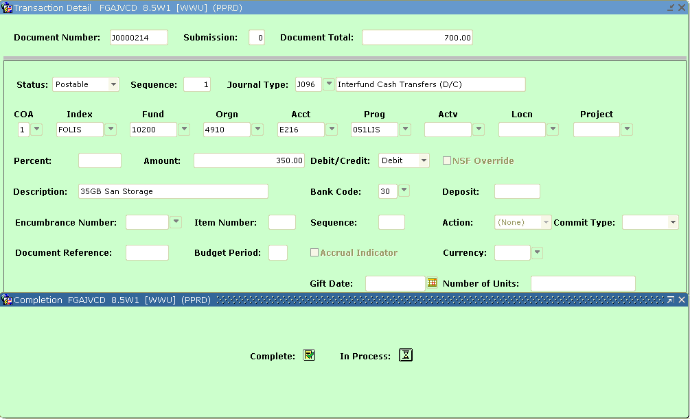

Click on the “In Process” button if you’d like to save this JV, but are not ready to send it to approvals. Everything you’ve entered will be saved. The document will remain in an incomplete status, allowing you to re-open it later. This can be useful when:
- you’d like to go to OnBase to attach supporting documents before completing the JV
- you’re entering a JV with many sequences and wish to resume data-entry later

Note: To leave it “in process”, the JV must be balanced (Credits = Debits) and must add up to the Document Total. If you’ve not yet entered all the sequences, you can Previous-Block back to the header to adjust the Document Total.

If you’ve finished data-entry and are ready to send the JV to approvals, click on the “Complete” button. When you click on Complete, a “forwarded to approvals” message will appear at the bottom of the screen. You will no longer be able to open this JV on FGAJVCD or FGAJVCM (unless it is subsequently disapproved, which returns it to an incomplete status).

□ □ □

Your cursor will be returned to the Document Number field at the top of the screen. You may enter another JV, or click on the “X” icon to exit to the menu.

□ □ □ □ □ □ □ □ □

Creating a JV on FGAJVCM

To begin data-entry, type “FGAJVCM” in the Go box on the Banner main menu. The form will open, with the cursor in the Document Number field:

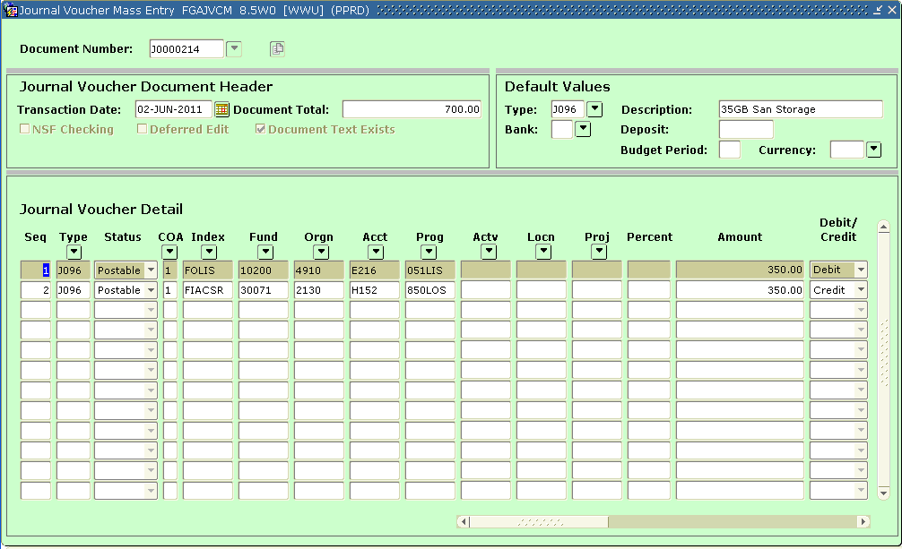
Note that the header and detail display on one page (on FGAJVCD, the header and detail are on separate pages).

Document Number: Leave this blank to have Banner assign an 8-character document number that starts with a “J”, e.g. J0000214. Or, enter your own number. (Banner will prevent you from entering a document number that has already been used.)

□ □ □

Move to the next block to enter the header.
Next Block <Ctrl-PgDn> or or Block, Next

Entering the header on FGAJVCM

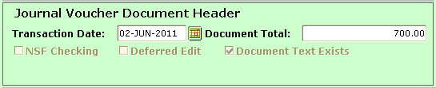

Transaction Date: Defaults to the current date. If desired, change to any date in an open period. This determines the fiscal period for posting.

NSF Checking: Leave this field blank.

Defer Edit: Leave this field blank.

Document Text Exists: Display-only. Grayed-out if no explanation (document text) has been entered. Will display a tickmark when document text has been entered.

Document Total: Enter the amount which is the sum of the absolute values of the accounting sequences you will enter. For example, if you’ll be entering a debit for 250.00 and a credit for 250.00, the document total will be 500.00.

Entering default values on FGAJVCM

Entering default values is optional. However it can speed data-entry, as these fields will automatically populate the matching fields in the detail block. Defaults can be overwritten in the detail block.

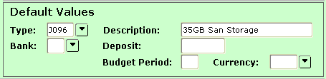

Type: Enter the default rule class – see the list on page 7.

Description: Enter the default description.

Bank Code: Leave this field blank. Banner will populate the appropriate bank code on the detail records, based on the Fund code.

Deposit: (optional) Usually left blank. It is used on JVs that pertain to banking activity.

Budget Period: Leave this field blank. Budget periods are not used on accounting JVs.

Currency: Leave this field blank.

Entering the explanation on FOATEXT

To enter an explanation for this JV (mandatory), turn to page on page 21 and follow the instructions for data-entry on FOATEXT. When you’re done, return to this page.

□ □ □

When an explanation has been entered, move to the next block to enter the detail (accounting sequences).
Next Block <Ctrl-PgDn> or or Block, Next

Tip: Your Banner-assigned Document Number will now be displayed.
Before going any further, write this number down.
You’ll need it later when attaching images in OnBase.

Entering detail on FGAJVCM

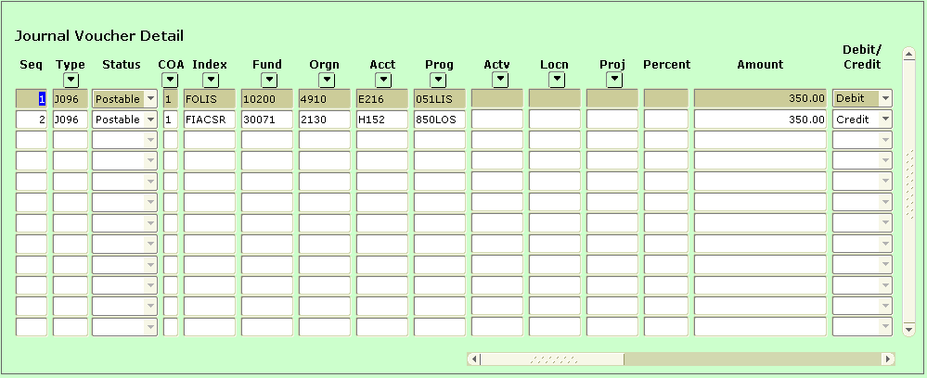

Sequence: Leave this blank. Banner will assign a sequence number as you exit the field.

Journal Type: Default value will populate, but can be overwritten. If default was left blank, enter the appropriate rule class – see the list on page 7.

COA: Enter the chart for this sequence.

Index: (optional) Enter the fast index for this sequence.

Fund: Enter the fund code for this sequence.

Orgn: Enter the organization code for this sequence.

Acct: Enter the account code for this sequence.

Prog: Enter the program code for this sequence.

Actv: (optional) Enter the activity code for this sequence.

Locn: (optional) Enter the location code for this sequence.

Project: (optional) Some departments use this field to record reference numbers. For example, this field is used by the Travel Desk to enter travel authorization numbers.

Percent: (optional) Enter the percentage of the document total charged to this sequence. As you exit the field, Banner will calculate the amount and display it in the Amount field.

Amount: If you entered a percentage in the previous field, this will display the amount Banner calculated for this sequence. Otherwise, enter an amount here.

Debit/Credit: Select either “Credit” or “Debit” from the list.

Optional: Using the scroll bar at the bottom, scroll to the right to do data-entry in additional columns. This data-entry is only required if (a) you did not populate the default values block, or (b) you did populate it and want to overwrite a default.
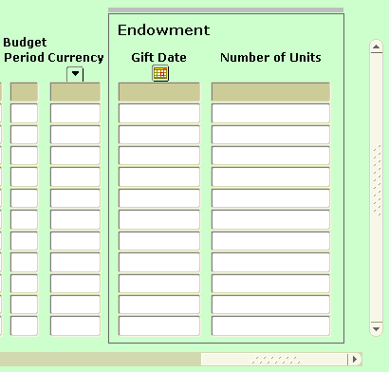
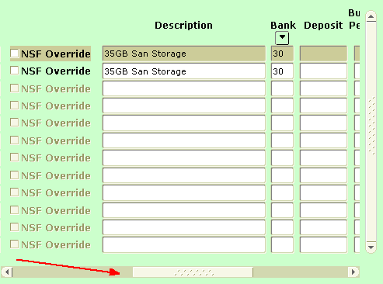

NSF Override: Leave this field blank.

Description: Default value will populate, but can be overwritten. If default was left blank, enter the description for this sequence.

Bank Code: Leave this field with the default value. Banner populates the appropriate bank code, based on the Fund code.

Deposit: (optional) Default value will populate, but can be overwritten.

Budget Period: Leave this field blank. Budget periods are not used on accounting JVs.

Currency: Leave this field blank.

Gift Date: Leave this field blank. (Used by the Endowment module unitization process.)

Number of Units: Leave this field blank. (Used by the Endowment module unitization process.)

□ □ □

To enter another accounting sequence, insert a record.
Insert Record <F6> or or Record, Insert

Enter the detail for each new accounting sequence as described on the preceding pages. Banner will automatically increment the sequence number as you add additional records.

If you need to return to the previous block (to correct the Transaction Date or Document Total, or enter an explanation on FOATEXT), use the previous block command.
Previous Block <Ctrl-PgUp> or or Block, Previous

When all sequences have been entered, move to the next block to complete the JV.
Next Block <Ctrl-PgDn> or or Block, Next

Completing the JV on FGAJVCM

The Completion block appears at the bottom of the screen:

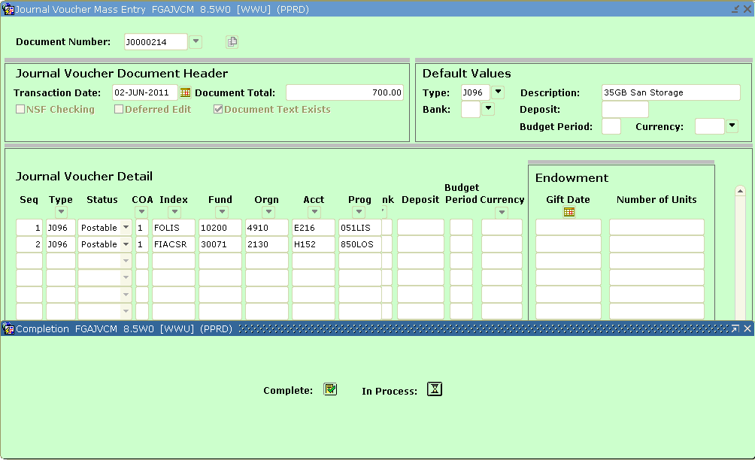

Click on the “In Process” button if you’d like to save this JV, but are not ready to send it to approvals. Everything you’ve entered will be saved. The document will remain in an incomplete status, allowing you to re-open it later. This can be useful when:
- you’d like to go to OnBase to attach supporting documents before completing the JV
- you’re entering a JV with many sequences and wish to resume data-entry later

Note: To leave it “in process”, the JV must be balanced (Credits = Debits) and must add up to the Document Total. If you’ve not yet entered all the sequences, you can Previous-Block back to the header to adjust the Document Total.

If you’ve finished data-entry and are ready to send the JV to approvals, click on the “Complete” button. When you click on Complete, a “forwarded to approvals” message will appear at the bottom of the screen. You will no longer be able to open this JV on FGAJVCD or FGAJVCM (unless it is subsequently disapproved, which returns it to an incomplete status).

□ □ □

Your cursor will be returned to the Document Number field at the top of the screen. You may enter another JV, or click on the “X” icon to exit to the menu.

□ □ □ □ □ □ □ □ □

Creating Document Text on FOATEXT

For each JV, you must enter document text which explains why the JV is being created.

Document text can only be entered while you’re in the header block of FGAJVCD, or the header/default block of FGAJVCM. The option to enter header text is not available when you’re in the detail or completion block of those forms.

To enter text, click on “Options” on the menu, then “Document Text”. The FOATEXT form will open, with the cursor in the top row of the text block:

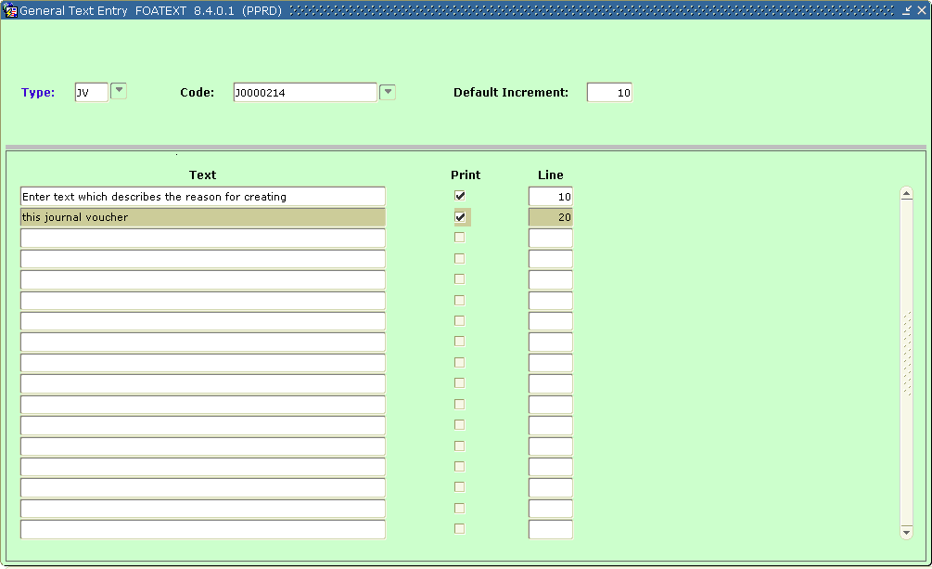

Lines of text do not wrap – instead, each is a separate record. Enter each line of text as follows:

Text: Enter up to 50 characters. You can use letters, numbers, or special characters, e.g. asterisks or dashes.

Print: Tick this to have that line of text displayed on the Web4U “View document” page.

Line: Used for sorting the lines. Defaults to increments of 10, though smaller increments can be used to rearrange lines of text. For example, if you’ve already entered lines 30 and 40, use 35 to insert a line in between – the lines will be resorted when the text records are saved.

To enter additional lines of text, use the down-arrow to go to the next blank record. Enter as many lines of text as are required.

When you’re done, click on the “X” icon to exit FOATEXT.

A message will appear, asking you if you wish to save the records. Say “Yes”.

When you say “Yes”, Banner will save your text, and then return your cursor to wherever you previously were on FGAJVCD or FGAJVCM.

□ □ □

Now return to your previous page (pg 9 for FGAJVCD; pg 16 for FGAJVCM)
for instructions on entering detail and completing the JV

□ □ □ □ □ □ □ □ □

Adding Attachments with OnBase

Open OnBase:
- Open OnBase from your computer (You can search the list of programs - Hyland Unity Client)
  - Click WWU SSU
- OR….Log into MyWestern, under “Administrative Tools”, click on “OnBase Unity Web”.

Import Documents in OnBase

- Along the top navigation ribbon click Import. (For the OnBase Unity Web click (the hamburger) and select Import Document.)
- In the left navigation, click the Document Type drop down arrow.
  - Select ACCTG – Journal Voucher.
- Enter Journal Voucher Number (required) and other keyword data as needed.
- Select a file to import
  - Click Browse on the top navigation.
  - Or drag and drop files into the preview area.
- Preview the file.
- Click import. Or click cancel if the wrong file was imported.

Repeat steps 4 through 6 until all documents are uploaded.
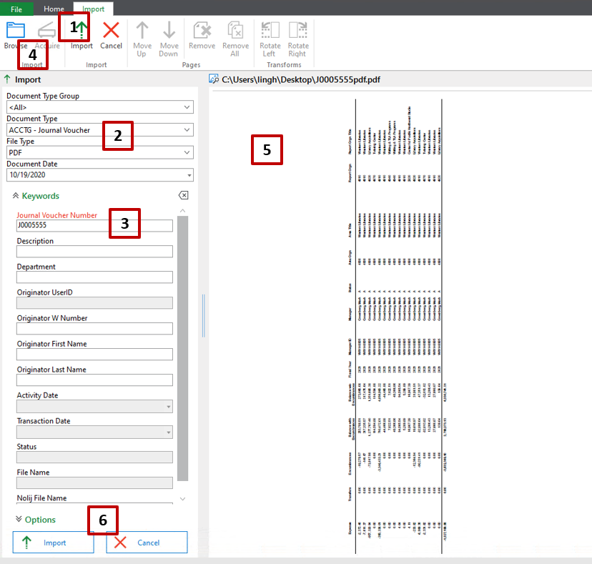

The Document View window opens.

- Add Sticky Notes, Re-Index (change document type), add keywords and more.
- Note if you are viewing a MS Word document you can add highlights, bold text and more using MS features, same for PDFs.

Logging out from OnBase

When you’re ready to exit OnBase, close the window

Viewing JV Details or Approval History in Web4U

From the Web4U “View Document” page, you can:
- open a separate OnBase window
- view or print the JV header, text, and accounting sequences
- view or print the JV approval history

Log into Web4U, select “Finance”, “View Document”. The View Document page will open:

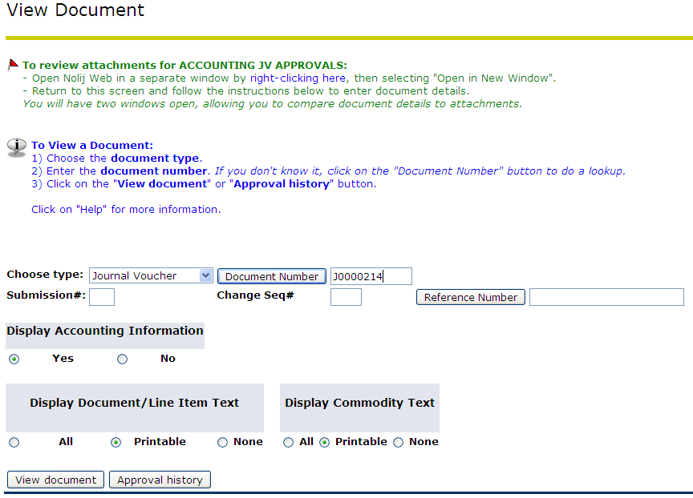

Opening a separate OnBase window through Web4U

- Right-click on the link provided, then select “Open in New Window” in the popup menu.
- Log into OnBase in the other window – see page 23 for more information.
- Return to the Web4U window to search for the document.
- Using the two open windows, compare document details to the attachments.

Viewing JV details on Web4U

- If you have both OnBase and Web4U open, select the Web4U window.
- Select document type “Journal Voucher”.
- Enter the document number.
- Make sure “Display Accounting Information” says “Yes”.
- Make sure “Display Document/Line Item Text” says “Printable”, or “All”.
- Click on the “View document” button.

Document details will be displayed:

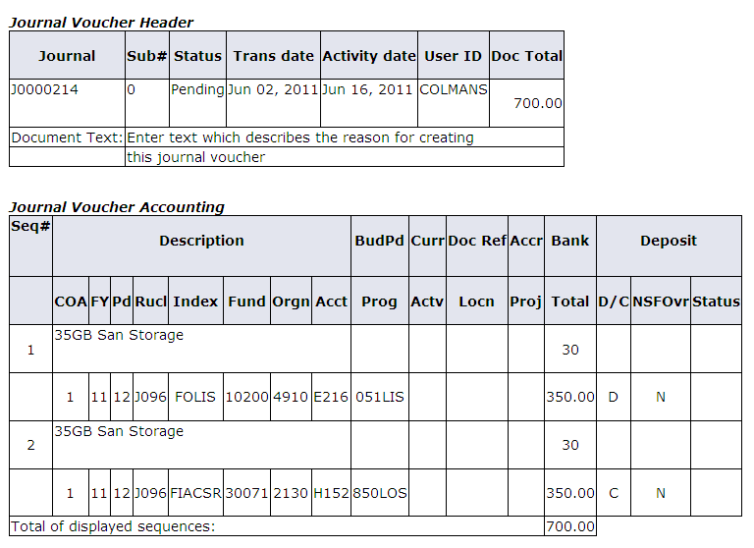
Detail record #2, wrapped
to 2 lines
Detail record #1, wrapped
to 2 lines

Header: The document header will show “Pending” while the JV is going through approvals. Once the JV has been final-approved and posted, this will change to “Posted”.

Text: If document text was entered, it appears under the header.

Detail: Each accounting detail record wraps to two lines. This includes the description, rule class, FOAPAL, credit/debit indicator, and amount.

Viewing JV approval history on Web4U

- In the Web4U “View Document” window, select the document type.
- Enter the document number.
- Click on the “Approval history” button.

The document’s approval history will be displayed.

All of the approvals that still have to occur for this document will be listed under “Approvals required”. This shows each queue that the document must pass through, and the names of the potential approvers in each queue.

If no approvals have yet occurred, the message “No approvals have been recorded for this document” will display at the bottom of the screen. For example, the JV shown below requires five approvals, and none of them have occurred yet:

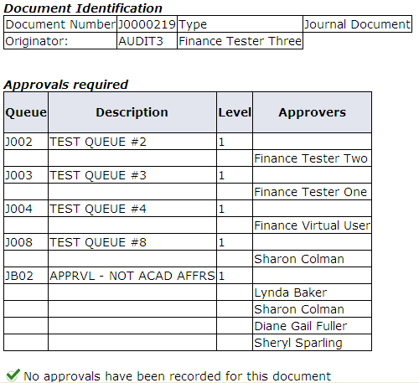

Note: For each queue, only one of the potential approvers has to approve the document in order for it to move along to the next queue. In the example shown above, queue “JB02” shows four potential approvers. Only one of these people has to approve the document. Once they have approved it on behalf of that queue, the queue name will be dropped from “Approvals required”.

If some approvals have already occurred, the display will list those that have already occurred under “Approvals recorded”. In this example, two approvals have already occurred, and three more are still required:

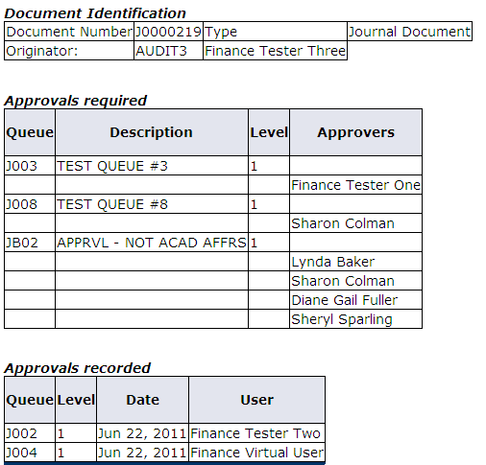
Three approvals remain
Two approvals completed

When approvals have been completed, the message “There are no approvals required at this time” will be displayed, instead of an “Approvals required” listing. All approvals will be listed under the “Approvals recorded” listing.

Note that if the last approval action was actually to disapprove the JV, that approval will show with the queue name “DENY”.

Printing JV details or approval history on Web4U

Follow the previous instructions to display either the JV details or approval history page. To print that page, select “File”, then “Print” from your browser menu. If you wish to preview this page first, select “File”, then “Print Preview”.

Approval/Disapproval Messages on GUAMESG

Each approval or disapproval action sends a message to the originator (plus any previous approvers to that JV). These messages appear on a form called GUAMESG.

Viewing GUAMESG messages

On the right-hand side of the Banner main menu, there is a link called “Check Banner Messages”. If a tickmark appears next to this link, it means at least one message is waiting for your attention:

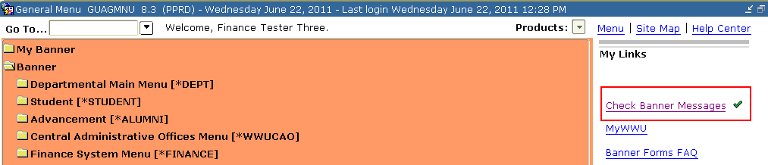

Click on the link, and the GUAMESG form will open. The messages listed can be for both approved and disapproved documents:

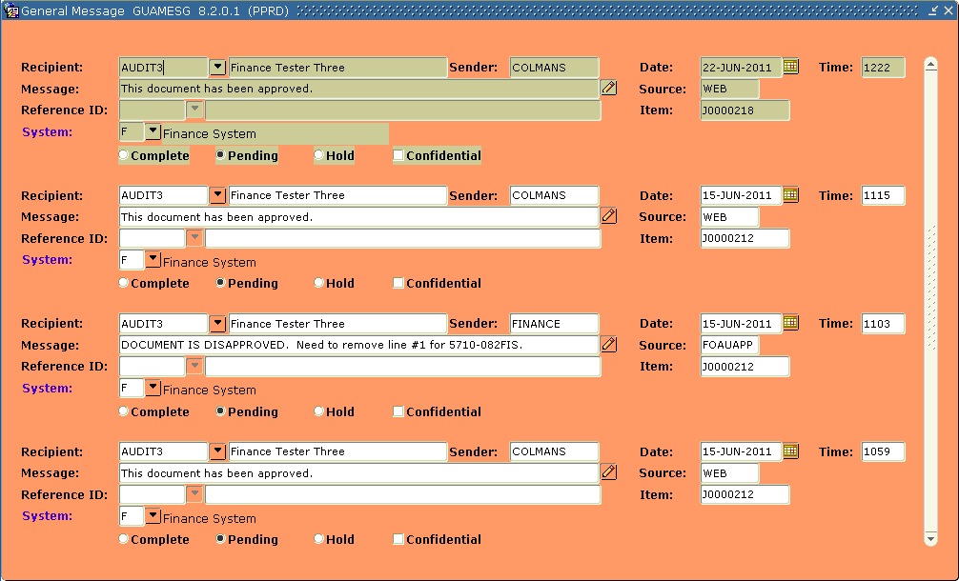

Note that each message has a radio button, indicating the message status. Messages start out with a status of “Pending”. Messages will stay on GUAMESG until they are marked “Complete”:

If a message is long and scrolls off to the right, use the arrow key to move the cursor to that message, then click on the icon at the end of the Message field that looks like a pencil.

This will open up a separate window where you can view the entire message:

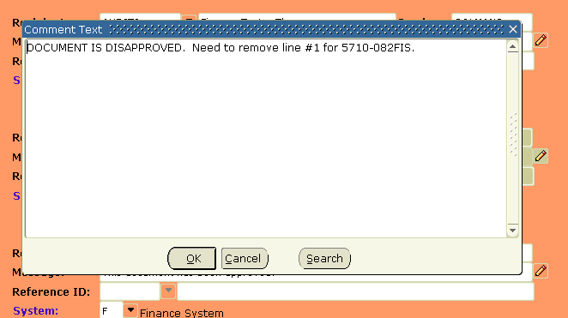

Click “OK” to close that window.

Completing GUAMESG messages

Originators need to keep their list of messages up-to-date, so that new messages will be apparent. Marking a message as “Complete” indicates that you have read and acted on the message and therefore no longer need to see it. This causes it to drop off your GUAMESG list.

Messages for disapproved JVs should be read carefully. If a disapproval message contains instructions on how to correct the document, make note of those instructions first, before marking it Complete.

Completing messages for approved JVs…

If a JV is marked with the message “This document has been approved”, you should:
- Finalize/file any paperwork you may use to track your submitted JVs
- Click on the “Complete” radio button
- Save the change.
Save <F10> or or File, Save

Completing messages for disapproved JVs…

If a JV is marked with the message “DOCUMENT IS DISAPPROVED” or something similar, you should:
- Look at the instructions from the disapprover. Is the JV being completely rejected, or does it need to be corrected? If correction is required, their disapproval message should tell you what correction is required.
- If correction is being requested, write down the message from the approver, or take a snapshot of the screen, to record their instructions. If you don’t have to time to do this, leave the message in “Pending” status until you do.
- When you’ve saved any correction instructions, click on the “Complete” radio button.
- Save the change.

Disapproved Documents

When a document is disapproved, a message is sent to the originator and all of the earlier approvers to that document. The message from the disapprover should describe whether the document is being completely rejected, or whether it simply needs correction. If it needs correction, the disapprover should describe what correction is required. (see page 30 for more information on messages)

If you’ve been sent a message that a JV is disapproved, and the approver has sent instructions on how to correct it, you will need to re-open the document in one of the data-entry forms, correct it, and complete it. It will once again go through the entire approvals cycle.

Correcting the JV

You can correct the JV on either one of the data-entry forms, unless you know you need to change a Document Reference Number. If you need to correct/enter a Document Reference number, use the FGAJVCD form. Otherwise, you can use either FGAJVCD or FGAJVCM.

When you correct an existing JV, all of the fields/values that you previously entered will be pulled into the form. Make corrections as stipulated in the message from the disapprover.

To correct the JV using the FGAJVCD form:
- Type “FGAJVCD” in the Go box on the Banner main menu
- Enter the JV document number into the Document Number field.
- Leave the Submission Number as “0”.
- Next-block to the header.
- Change the Document Total if necessary (this will only be necessary if you are adding or deleting detail lines, or changing amounts on the existing lines)
- Make your corrections, following the FGAJVCD data-entry instructions which begin midway down page 8.

To correct the JV using the FGAJVCM form:
- Type “FGAJVCM” in the Go box on the Banner main menu
- Enter the JV document number into the Document Number field.
- Next-block to the header.
- Change the Document Total if necessary (this will only be necessary if you are adding or deleting detail lines, or changing amounts on the existing lines)
- Make your corrections, following the FGAJVCM data-entry instructions which begin on page 15.

When your corrections have been made, complete the document. It will be submitted to the approvals stream once again.

