EVENT PITCH FOR WTA TRAIL
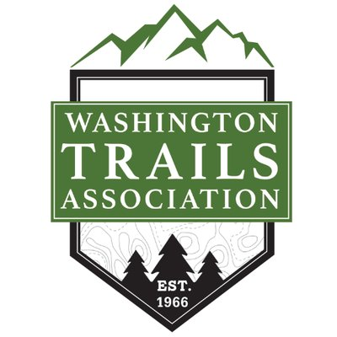

To generate excitement about the new WTA trail, an exciting idea would be to host a treasure hunt event before the official opening. This would entail people of all ages coming out to explore the new trail while also experiencing family time outdoors. The treasure hunt would have people looking for clues to find the treasure, aka a $250 gift card to REI, in addition to being able to take in the views from the trail while getting some exercise.

This event would gain traction with the public, while also drawing the attention of the media to write a story. When people can actively participate in the treasure hunt, they get to become familiar with the trail and see the beauty of it, therefore they will want to tell their friends about it too. A unique event like this would provide some great photo and interview opportunities for the media while giving WTA a platform to promote the new trail as well. The media would love an event like this because everyone in Bellingham would be talking about it!

