Zoom Instructions for Clients

Note: Thank you for being so flexible during these challenging times.

- Open your internet browser and type in ‘www.zoom.us’ in the search bar
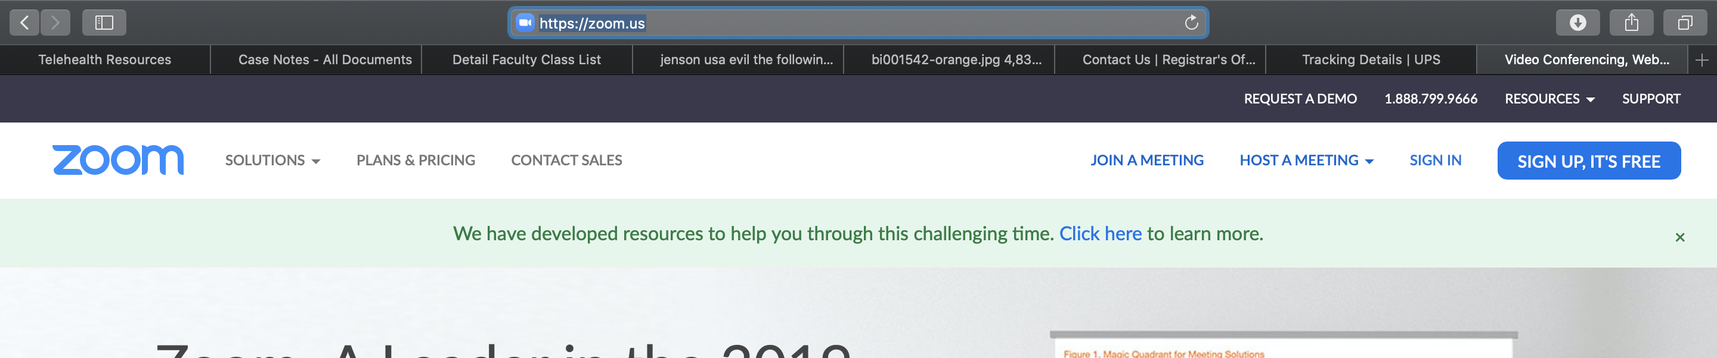
- Click on ‘Join a Meeting’
- Type in the ‘Personal Meeting ID’ that you received from your counselor
