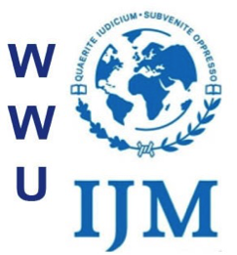

May 15, 2016

Kara Spencer
The Western Front

Dear Ms. Spencer,

International Justice Mission at WWU is a campus chapter of an international anti-human trafficking organization, and on June 4 will be hosting the second annual IJM at WWU Benefit Concert to raise awareness of human trafficking in Whatcom County. IJM at WWU is composed of a diverse range of students with a common goal of educating the Western community on human trafficking and how students can help support victims of human trafficking. The Front has covered IJM at WWU previously during their Stand4Freedom event and at last year’s Benefit Concert.

The Benefit Concert will take place in the Underground Coffeehouse at 7p.m. on Saturday, June 4 and will feature local bands, a keynote speaker, a club presentation and a raffle of local items.

Between 2007 and 2011, the percentage of homeless children rose 59 percent in Whatcom County, and many of those children are at risk for human trafficking. IJM at WWU seeks to educate and empower the Western campus and community through events like the Benefit Concert to help stop this abuse. Similarly, the AS club Western Students Against Violence is dedicated to raising awareness on issues that marginalized individuals, particularly women, face. They are closely partnered with Western Empowerment and Violence Education (WEAVE) and addresses issues of systemic enabling of violence and physical violence. IJM at WWU shares these goals and vision and hopes to create a campus coalition for social justice.

For more information, please contact me at (503) 804-8923 or ijmatwwu@gmail.com. We would love to have a reporter at this event.

Thank you,

Trisha Patterson

